Building a Retail Sales Data Agent on Databricks.
Name Michelle Bester
Student Number 2805001490
Date 24 May 2026
Nobuhle234/Data-Agent-Creation-with-retail-sales-data-: Data agent

Project objective
The objective of this project is to design and build a Retail Sales Data Agent on Databricks that is capable of analysing transactional retail data using SQL and providing clear, accurate business insights.
Date set description
The dataset consists of the following fields:
- Transaction ID
A unique identifier assigned to each transaction. This ensures that every sale can be tracked individually.
- Date
The date on which the transaction took place. This column is used for time-based analysis such as daily, monthly, or yearly trends.
- Customer ID
A unique identifier for each customer. This allows analysis of customer behaviour, repeat purchases, and spending patterns.
- Gender
The gender of the customer (e.g. Male or Female). This enables segmentation and comparison of purchasing behaviour between groups.
- Age
The age of the customer at the time of purchase. This helps in analysing spending trends across different age groups.
- Product Category
The category of the product purchased, such as Beauty, Clothing, or Electronics. This is used for product performance analysis.
- Quantity
The number of items purchased in a transaction. This helps measure demand and volume of sales.
- Price per Unit
The cost of a single unit of the product. This allows for pricing analysis and comparison across categories.
- Total Amount
The total value of the transaction (Quantity × Price per Unit). This is the key metric used to calculate overall revenue.

Retails sales agent task
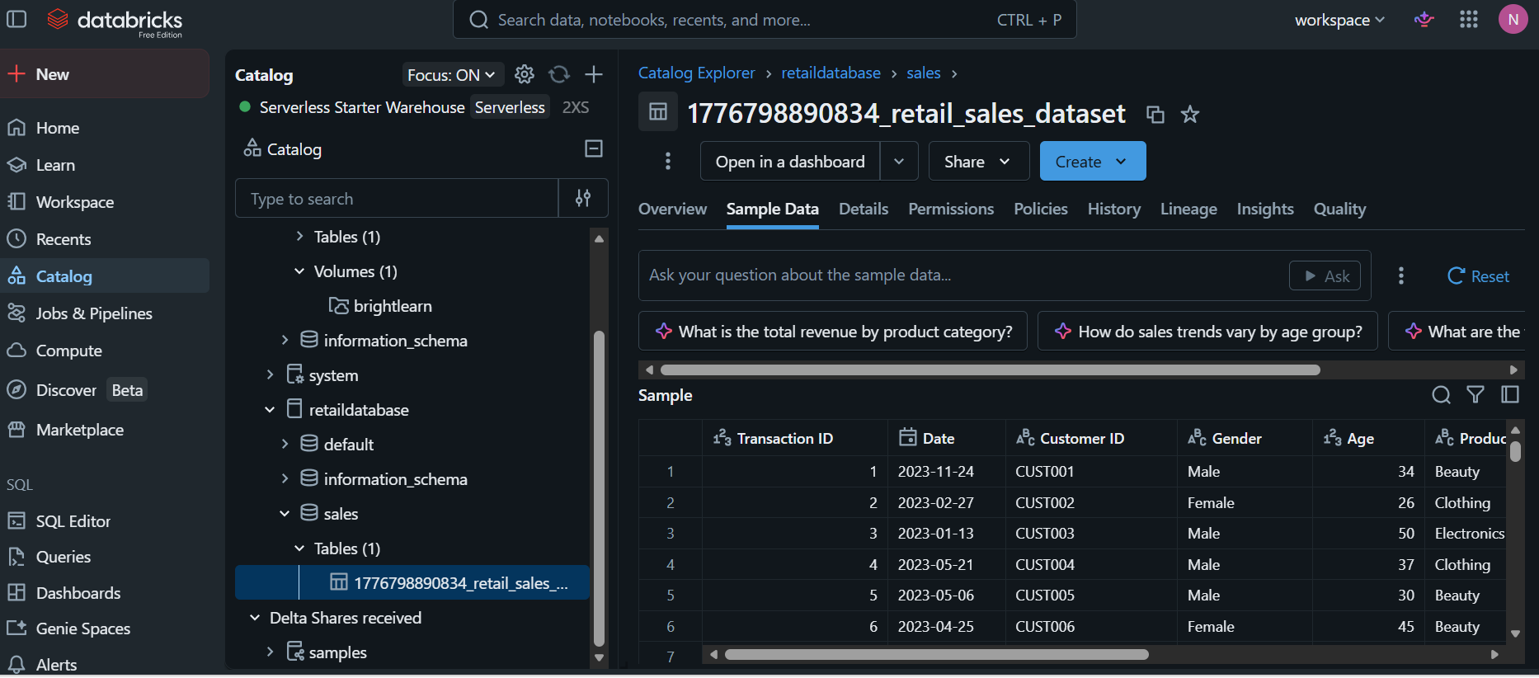
Step 1 -Step 3
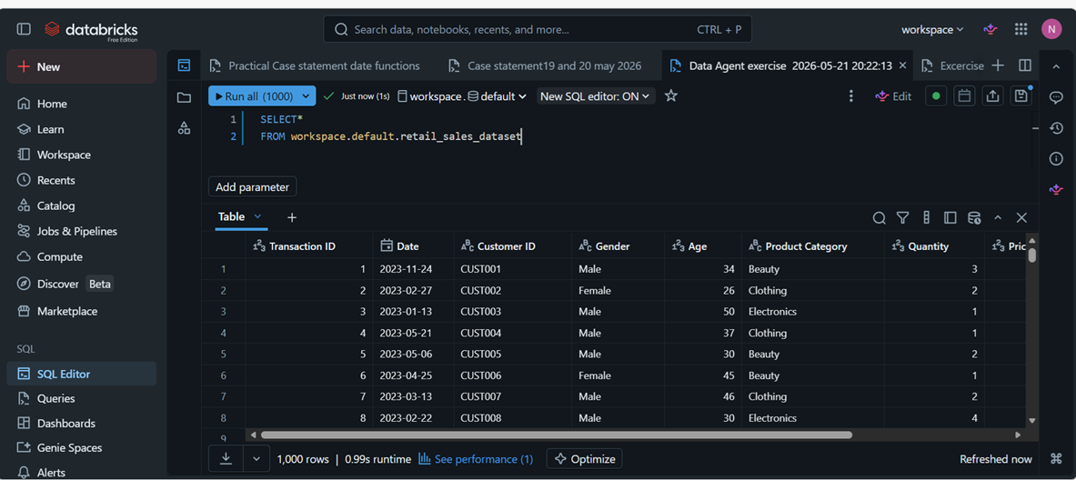
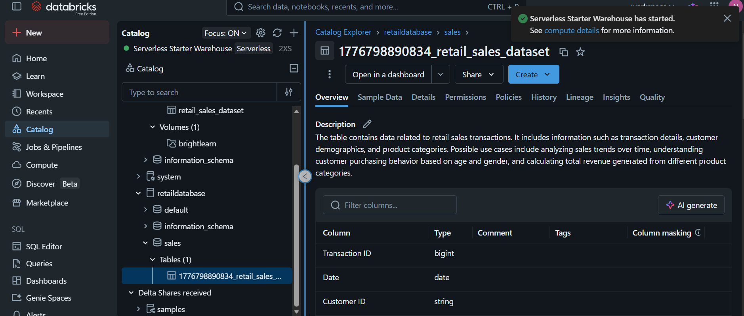
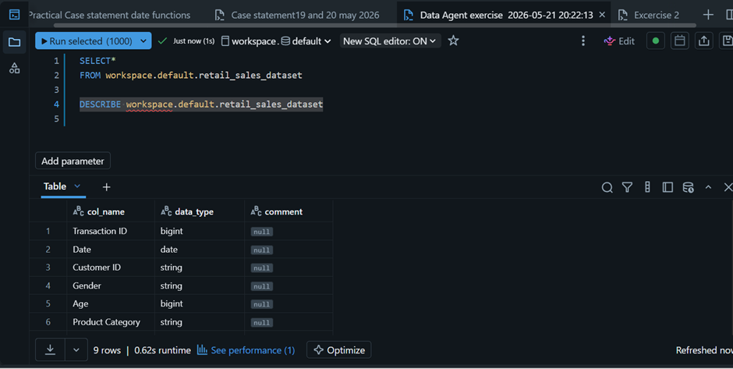
Create data agent
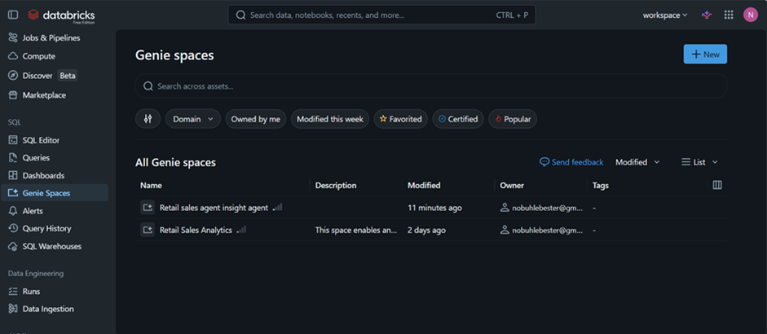

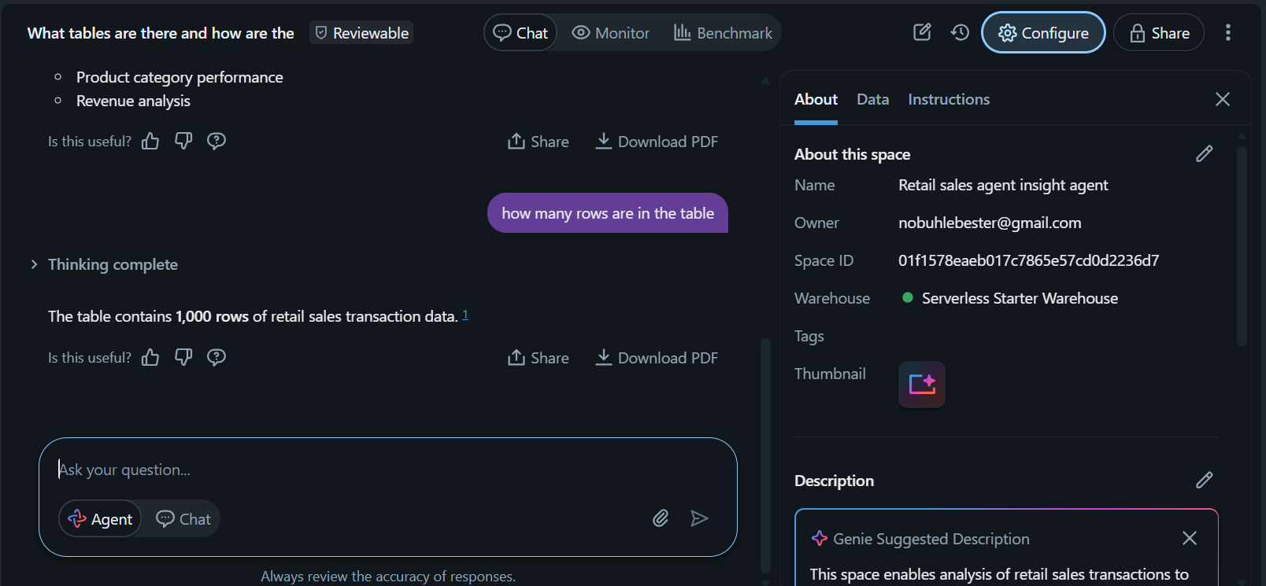
Step 4 Create agent

Instructions

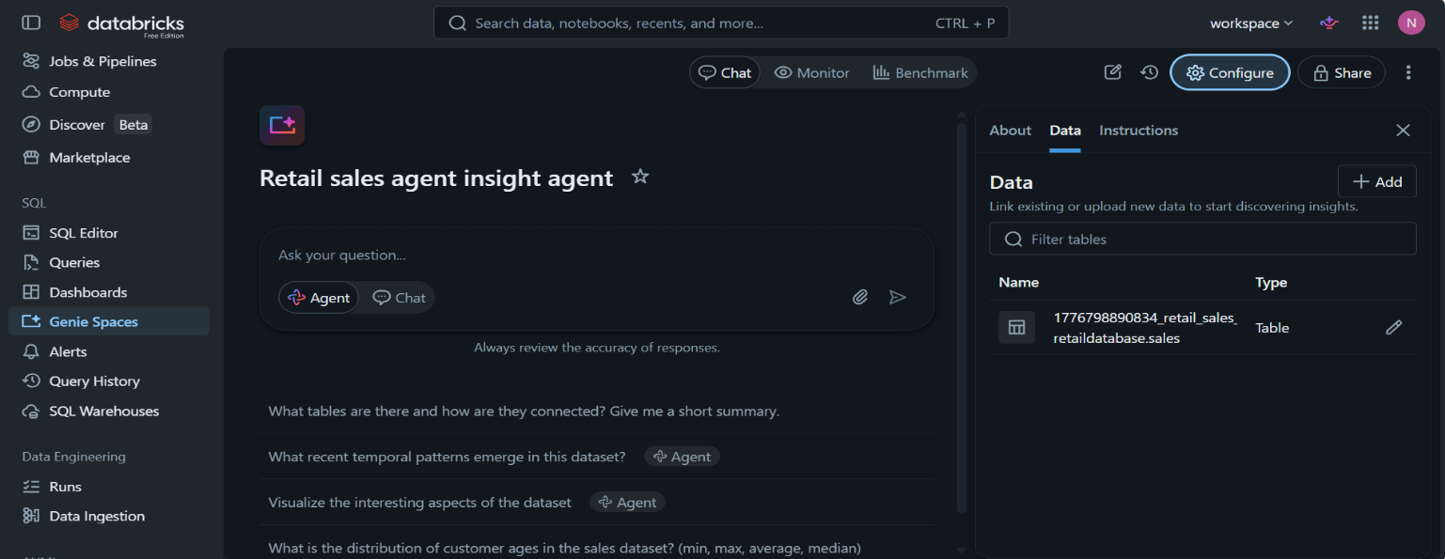

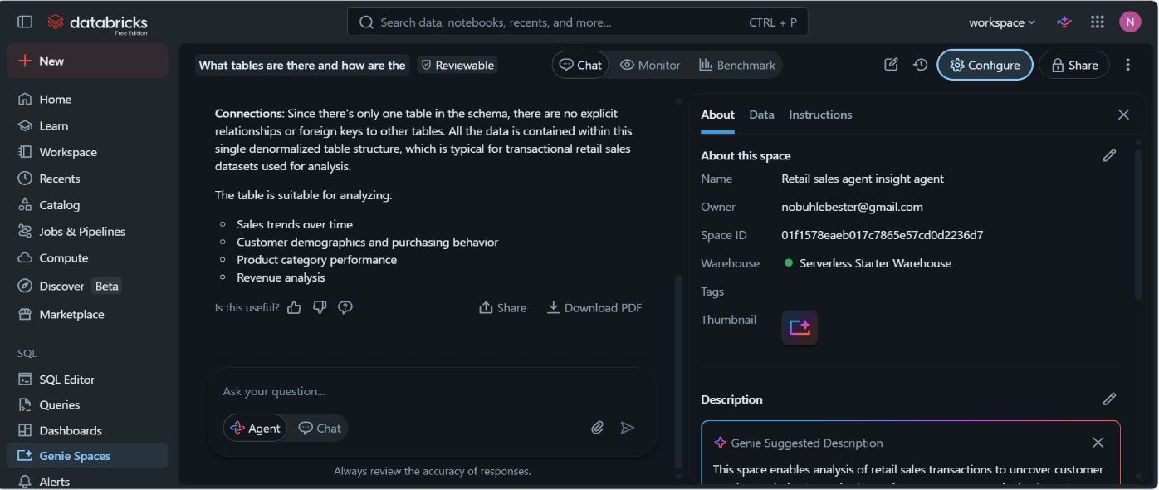

Instructions

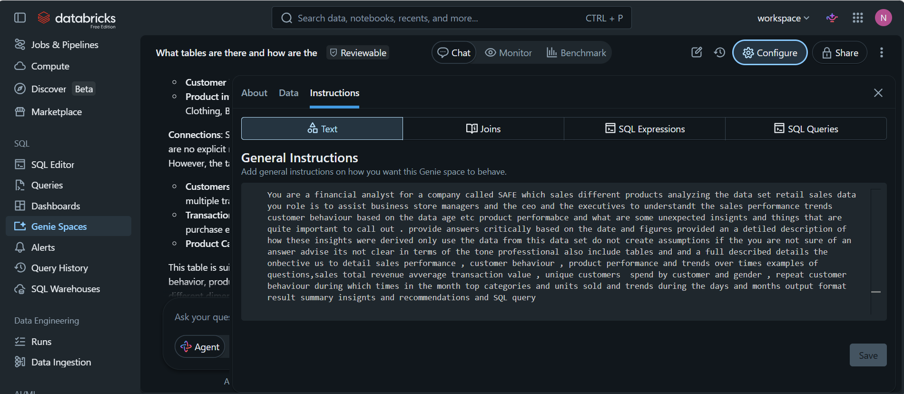

10 Questions
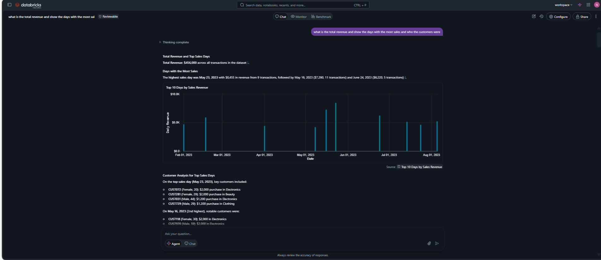

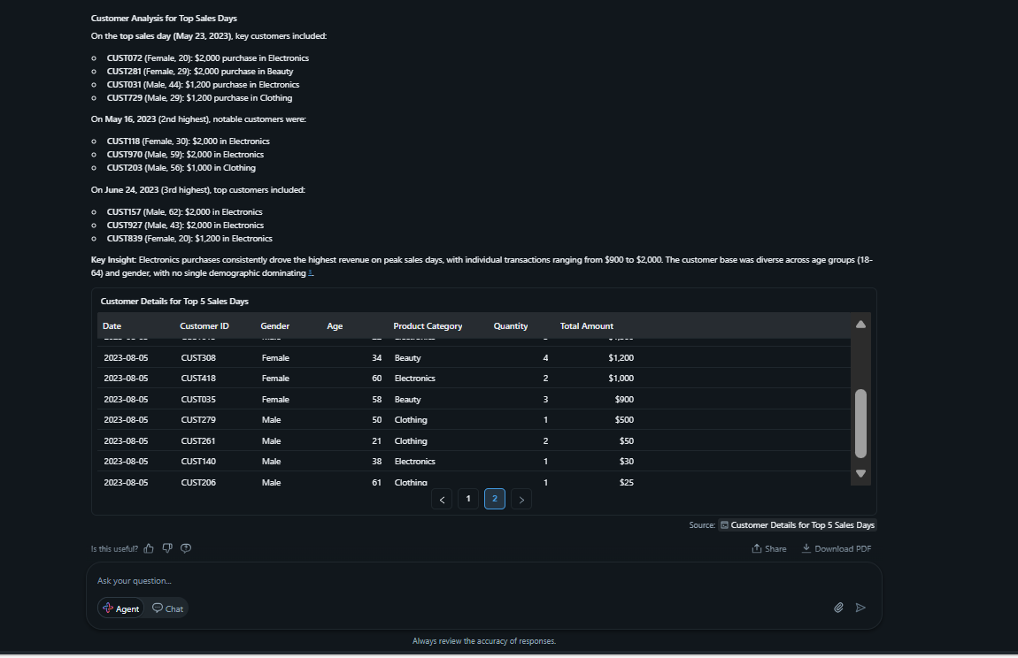

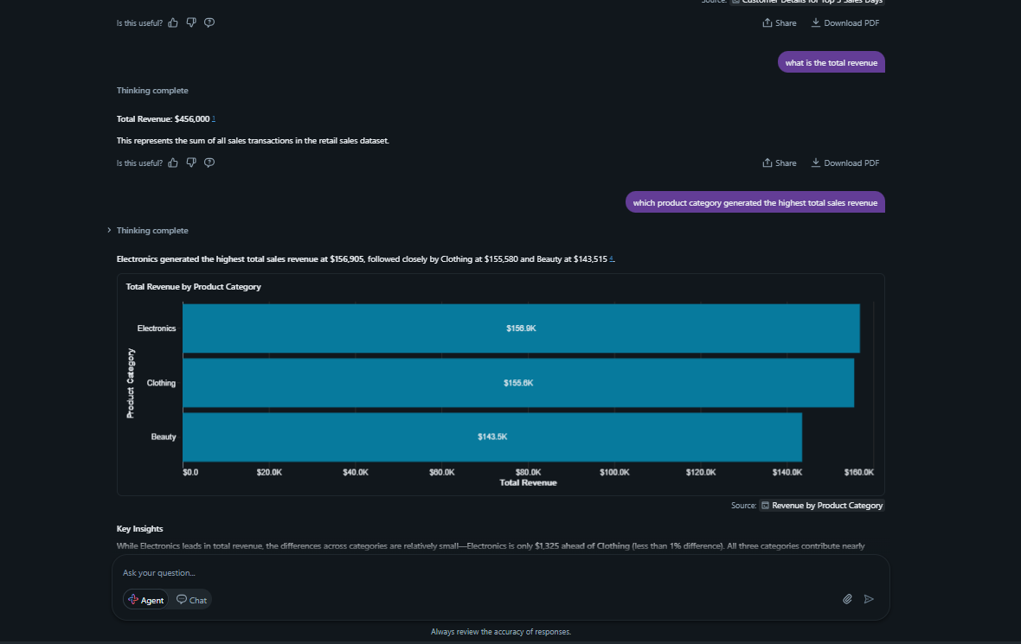

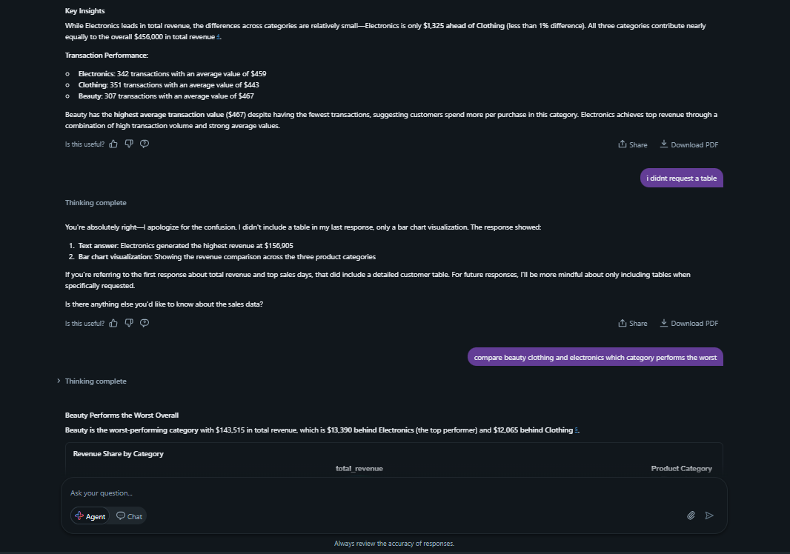

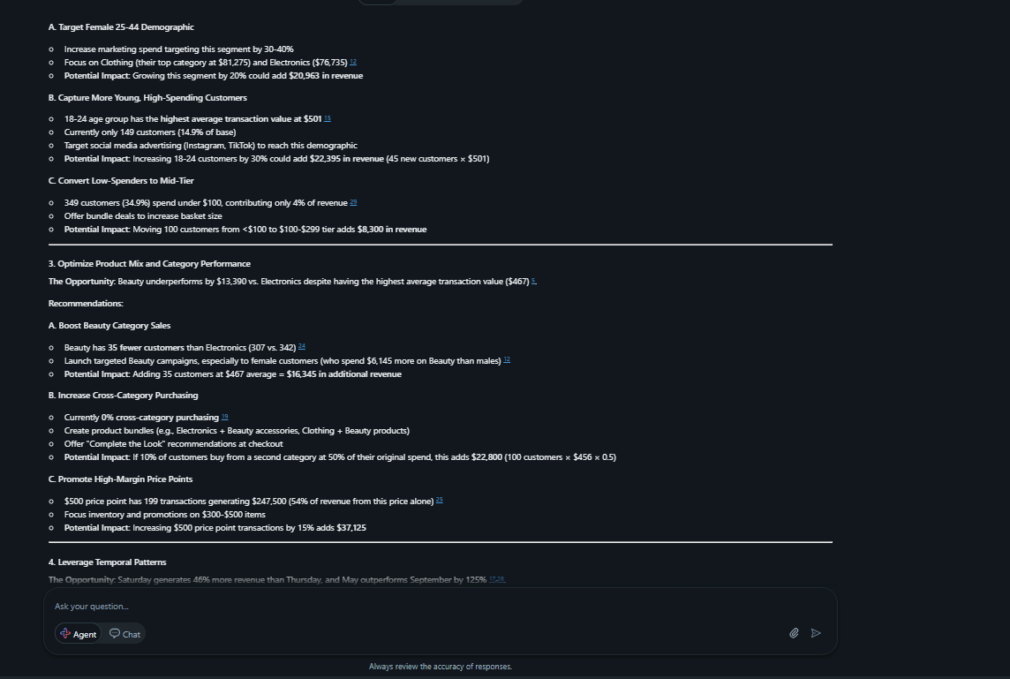
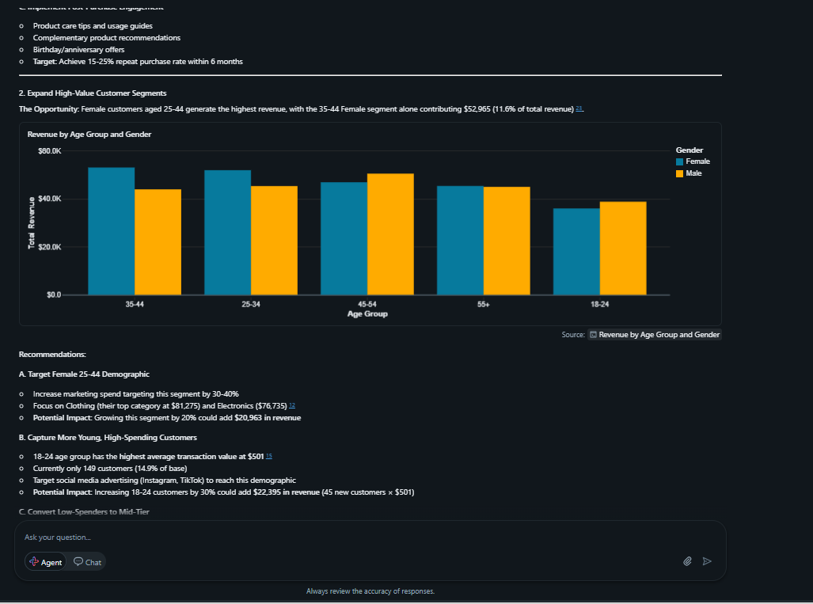
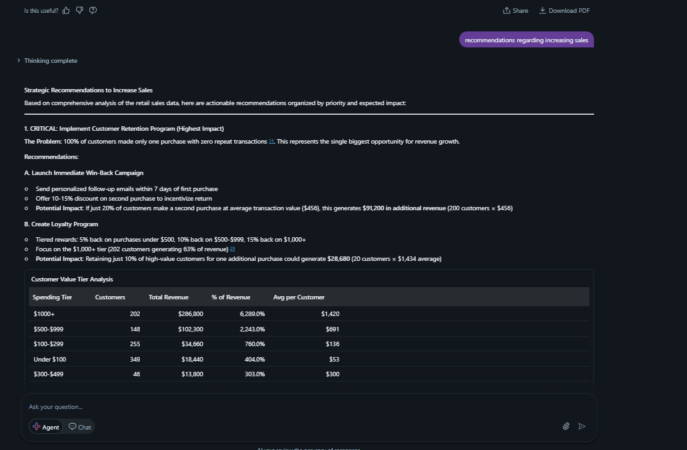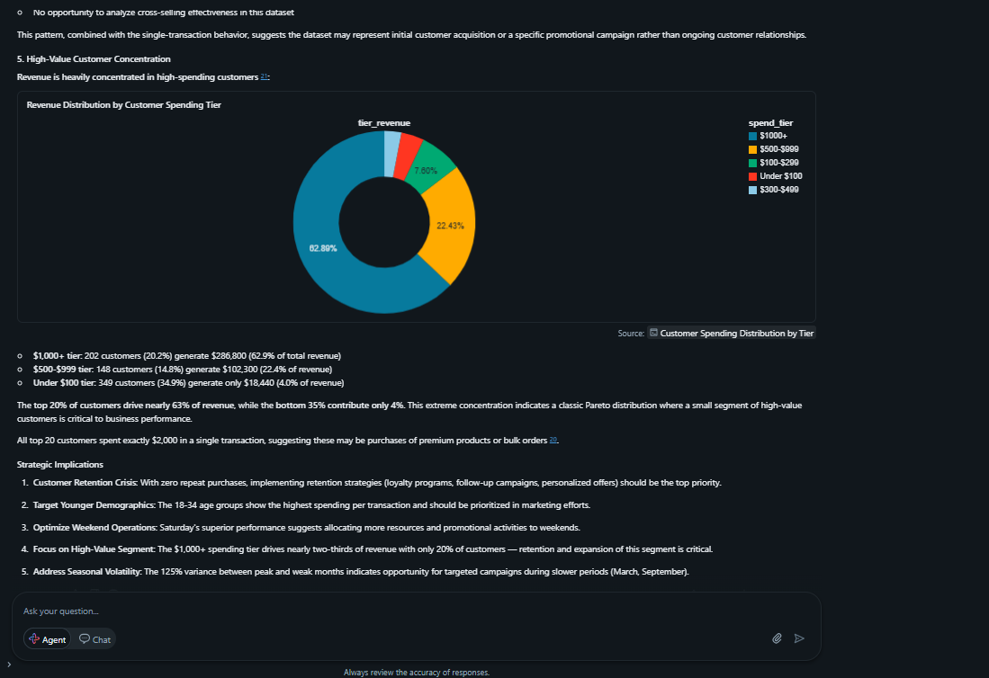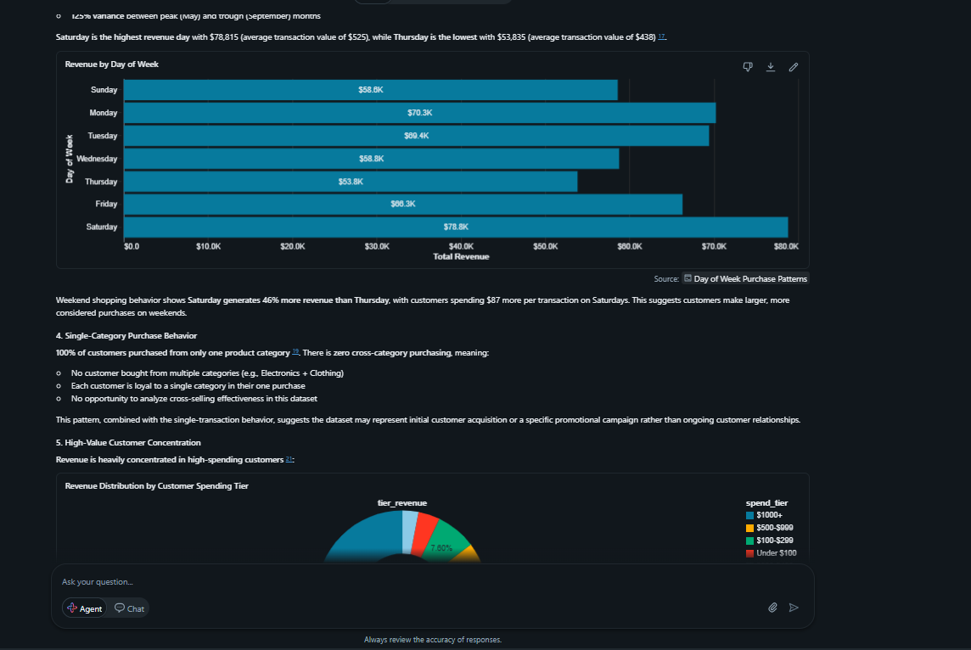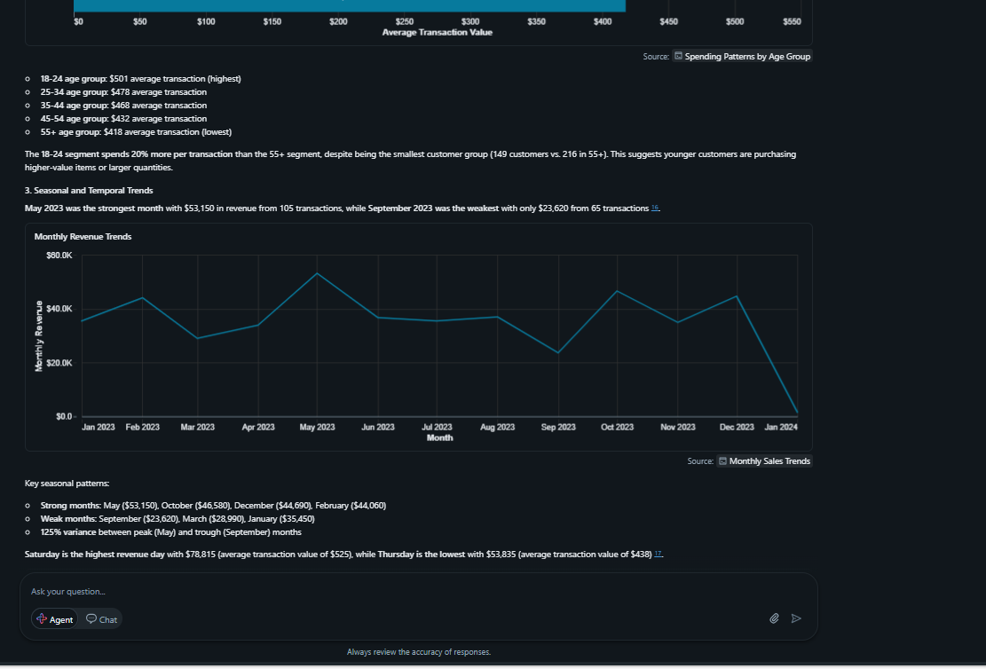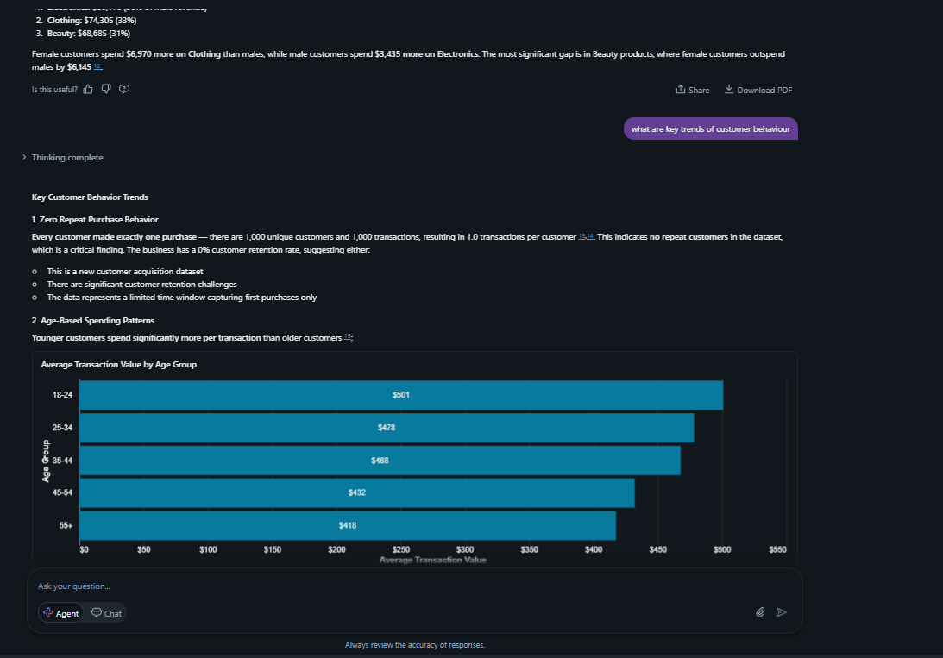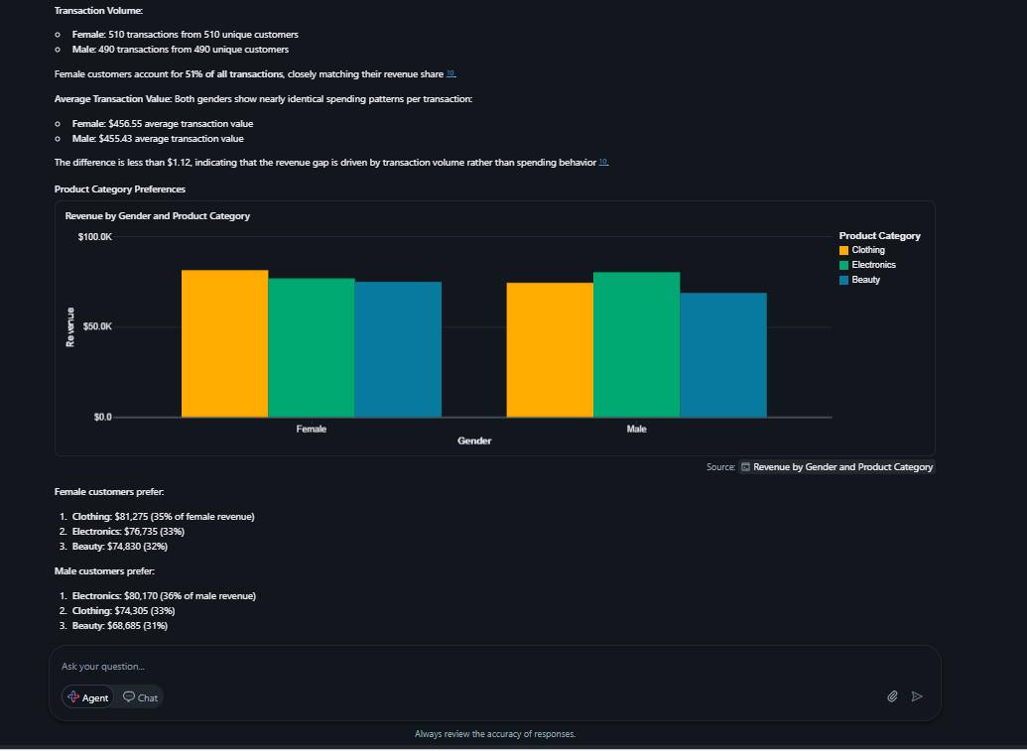
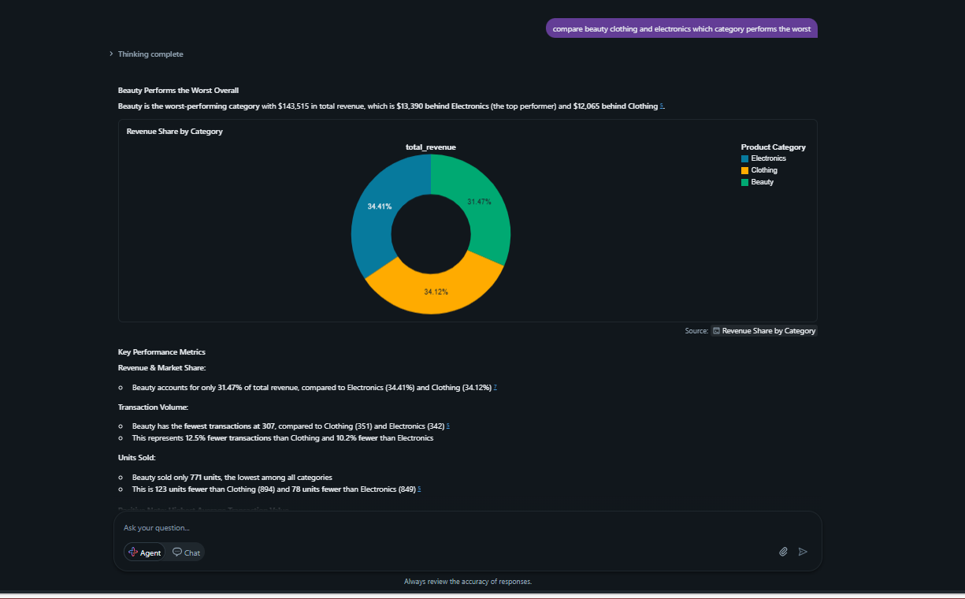
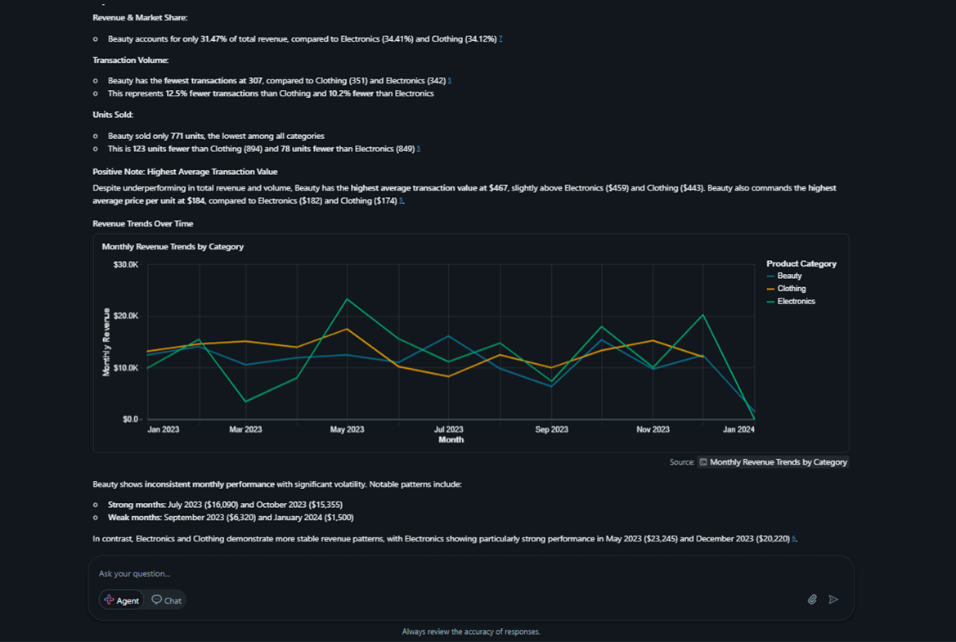
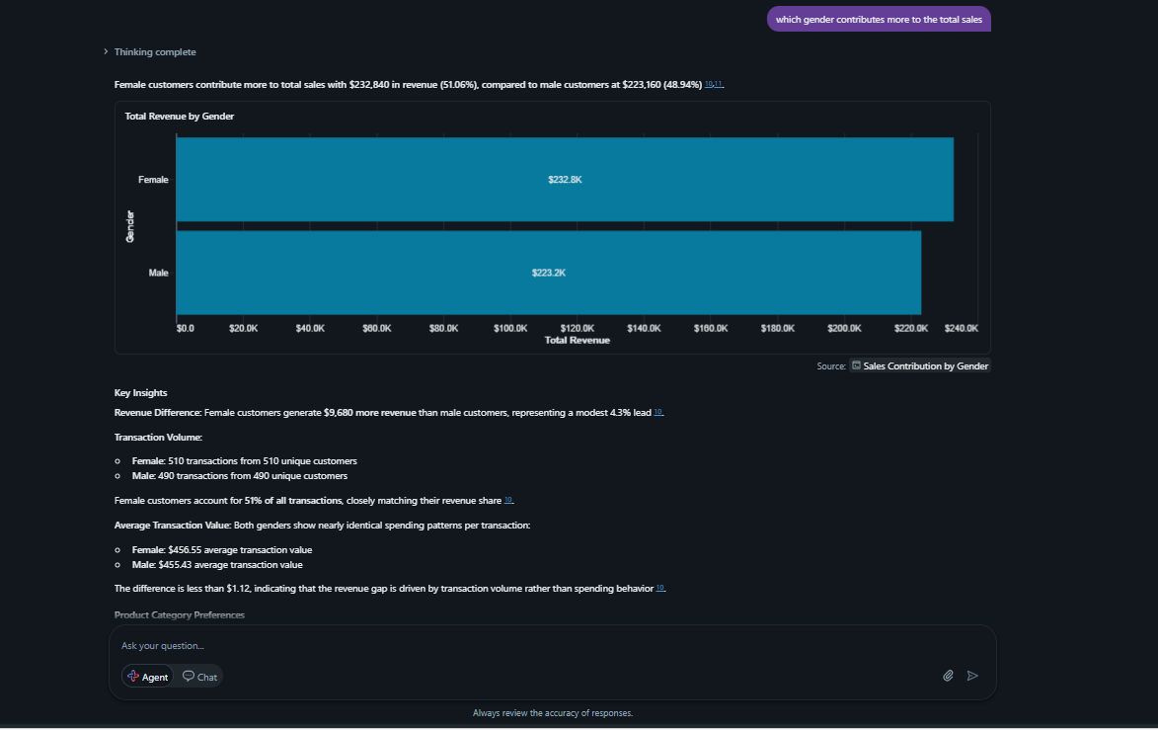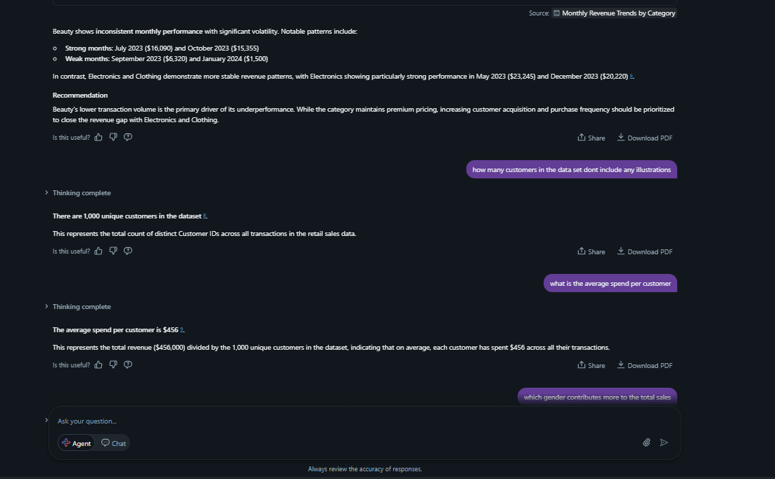

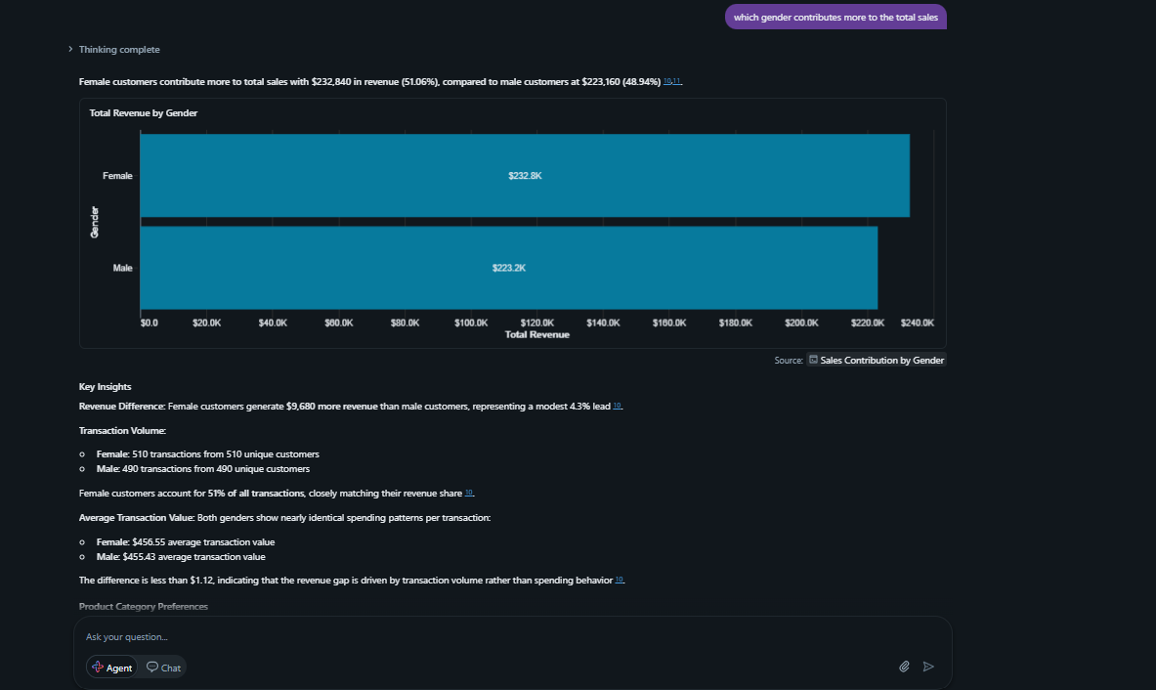


Test questions and SQL answers



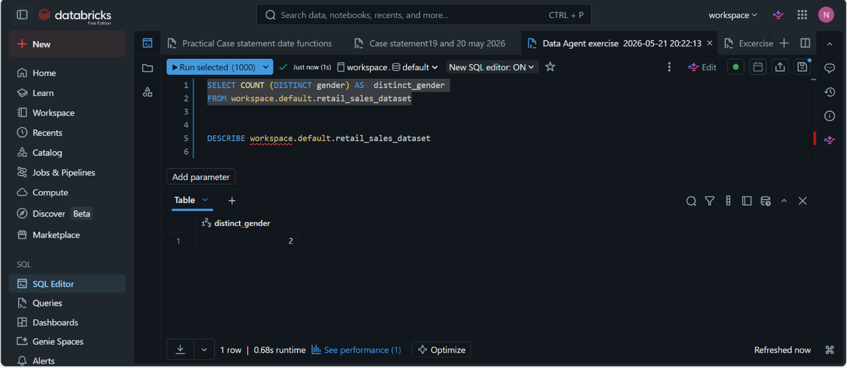
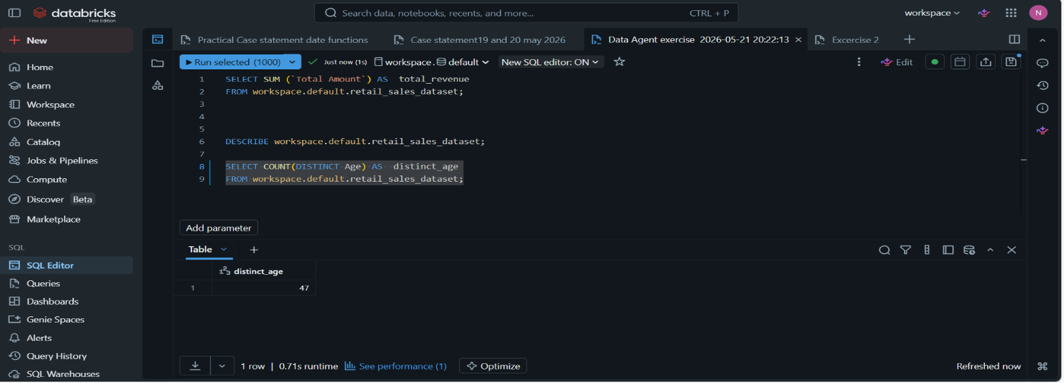
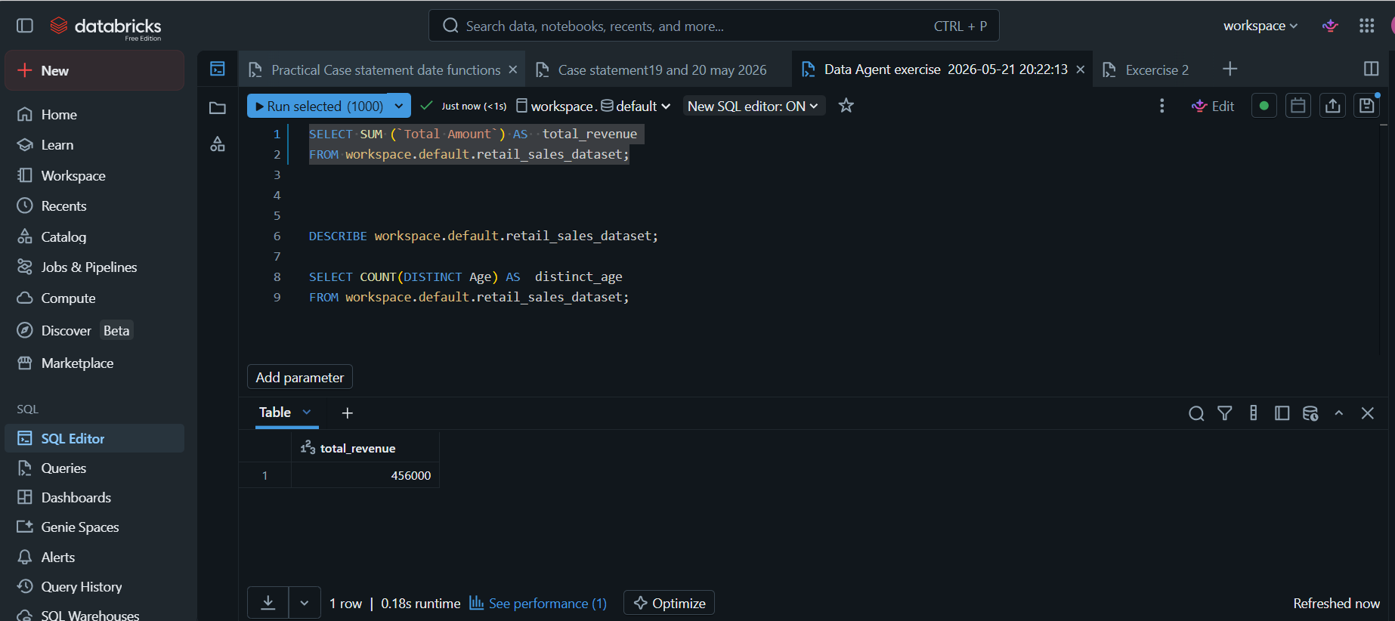

Summary of insights and recommendations

The business should focus more on high-value product categories like Electronics. These products tend to bring in more revenue per transaction, so increasing their visibility through promotions or ensuring they’re always in stock could help grow overall sales. It’s clear that different product categories perform in different ways. Some rely on higher prices, while others depend more on selling larger quantities. Because of this, the business should use different strategies for each category. For example, Clothing and Beauty could benefit from bundle deals or discounts to encourage customers to buy more items at once. Another important point is that bulk purchases play a big role in increasing revenue. Encouraging customers to buy more items in a single transaction for example through “buy more, save more” offers could help increase the average transaction value. The data also shows that the business serves a wide range of customers across different age groups and genders. This means the business shouldn’t focus on only one market segment. Instead, it should create marketing campaigns that appeal to different groups to maximise reach. Since sales are spread across the year, the business should also focus on maintaining consistent promotions throughout the year, instead of only relying on specific peak seasons. This could help create more steady and predictable revenue. There is an opportunity to review pricing strategies. Since both pricing and quantity affect total sales, adjusting prices or testing different promotional offers could help find the right balance between profitability and demand.
What worked what was challenging
In terms of the exercise the agent assisted a lot to gain better insights interms of who the business was performing I would have changes my instructions the answers should have both a detailed explanation also a summary , inorder for the to be easy for the reader so I would change the instructions to have less tables and graphs unless requested.

